# Year 11 Physics Notes (Modules 1-4)

## By Alex Gray

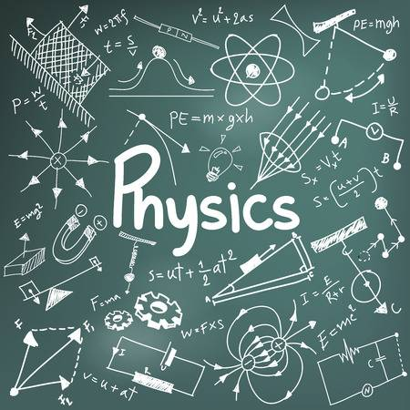

Contents

Module 1: Kinematics 4

Base Units 4

Equations 4

Course Notes 5

Significant Figures 5

Measurement Error 5

Vectors 6

Mathematical Notation for Vectors 7

Relative Vectors 8

A Note on Negative Vectors 8

Module 2: Dynamics 9

Base Units 9

Equations 9

Course Notes 11

Newton’s Laws 11

1st Law - **Inertia** 11

2nd Law - **Force** 11

3rd Law – **Law of Pairs** 11

Friction Forces 11

Tension Forces 11

Vector Diagrams 12

Conservation of Energy 13

Conservation of Momentum 13

Collisions 13

Elastic 13

Inelastic 13

Module 3: Waves & Thermodynamics 14

Base Units 14

Equations 14

Waves: 14

Thermodynamics: 15

Glossary 16

Course Notes 17

Properties of Waves 17

Frequency and Period 17

Energy of a Wave 17

Transverse vs Longitudinal 18

Transverse Waves 18

Longitudinal Waves 18

Graphing Compression Waves 18

The Ray Model 18

Refraction 18

Wavefronts 19

Refractive Index 19

Refraction and Refractive Index 19

Diffraction 19

Huygens’ Principle 20

Superposition 21

The Doppler Effect 22

The Doppler Effect Equation – A Strange Mistake 22

Standing Waves 23

Resonance 23

Entropy 24

Specific Heat 24

Latent Heat 24

Thermal Conductivity 24

“The Speed of Light”: The Universal Constant - c 25

Module 4: Electromagnetism 26

Base Units 26

Constants 26

Equations 26

Course Notes 29

Fields 29

Force Pairs of Fields 29

Electric Potential Energy 29

Electric Potential and Electric Potential Difference – Voltage 30

Current 30

Electrical Kinetic Energy and Power 30

Resistance 31

The Slightly more complicated explanation 31

A Strange Property of Resistance 31

Electron Spin and Magnetism 32

Magnetic Fields 32

Magnetism in a Wire with Current 33

Magnetism in a Ferromagnet 33

Magnetic Field Lines 33

Appendix 34

Tension 34

# Module 1: Kinematics

## Base Units

Mass () – Kilograms ()

Distance () – metres ()

Displacement () – metres ()

Time () – Seconds ()

Speed () – Metres per second ( **or**)

Velocity () – Metres per second ( **or** )

Acceleration () – ( **or** *)*

Equations

*Distance is equal to the magnitude of Displacement (i.e. without a direction)*

*Speed is equal to the magnitude of the Velocity (i.e. without a direction)*

*Average Velocity is the change in displacement over time*

*Average Acceleration is the change in velocity over time*

*Standard Kinematics equations.*

*NOTE: For interest sake, you can derive the first equation with respect to time to find the second equation. The equations themselves are integrals (reverse derivatives) assuming (i.e. acceleration is constant, or jerk is 0).*

## Course Notes

### Significant Figures

Sig. Figs are weird. However, the concept revolves around recursion and can be explained as such:   
*Any zero which can be written an infinite number of times in any direction while keeping the number the same, is not significant i.e. 1 = 1.0000000000000000… (The zeros can continue forever and are not significant). Therefore, any digit which is non-zero can be considered significant.*

When rounding to n significant figures, if there are more significant figures than required, merely round nth digit up if the next digit is 5 or higher and down if it is less.  
If there are less significant figures then all you have to do is add zeros to show that there is more precision in the answer. This is used when writing measurements, allowing the precision of the measurement to be given.

For example: *Your ruler measures to the nearest cm, but you found a stick to be exactly 100cm long. You could write that as ‘=1m’ but since your ruler measures to the nearest cm, you know with more precision how close it is to 1m. Therefore, you write it as =1.00m long.*

#### Measurement Error

Any measurement device has a recording error of ±1/2 of the units it measures in e.g. *a ruler that measures to the nearest cm has a possible error of ±5mm.*

Measurement error also relates to how you answer questions. Numbers are always given to the correct number of significant figures based off the measurement error. As such, you base your answer off the least accurate measurement.

When giving answers, ensure to give answers to the minimum number of significant figures present in the question.   
*e.g.* ***Find the force when accelerating a 5.00kg block at 10.00ms-2 (ignoring friction and air resistance):*** *The number of sig. figs in the mass of the block is 3 and the number of sig. figs in the acceleration is 4. Given the Force will equal 50N, we write it to the smallest number of sig. figs: 3. So our answer is 50.0N*

### Vectors

A vector quantity, denoted by an arrow ( ), possesses a magnitude and a direction. Unlike **Scalar** quantities, **Vector** quantities can be negative or positive, based on their direction. Vectors are a construct of the coordinate plane which we humans invented. Because this plane is relative, we can orient it however we wish. As such, it isn’t important which direction is positive, as long as vectors facing the opposite direction are negative with respect to each other.   
This can be seen in a velocity vector i.e. *5m/s North* is also ***-****5m/s South*. Equally, a *5m/s South* vector is ***-****5m/s North.*

Vectors can also be in multiple directions at once, for instance a velocity vector defined as   
*10 ms-1 (N 30˚ E)* is in both the North direction and the East direction. The magnitude which is in each direction is determined by the angle of the vector. In this instance we can use Sine, Cosine and Tangent ratios to solve for the magnitude in each direction. You can also apply this if you are given the separate components of a vector but not the whole vector, using the sum of the vectors to find the total vector. (Refer to Tutorial 5 in Book 1 for questions if unsure)

Vectors can also be added (*and multiplied but that’s not relevant yet*). When adding vectors, fundamentally you are adding their x-components and adding their y-components, therefore the first method to vector addition is just that. As such this is called the component method and uses the standard trigonometric ratios to find each component.

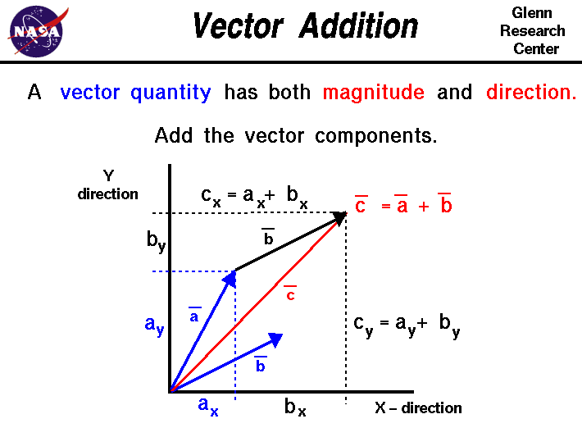The second method is a bit less indirect but works just the same, the Cosine rule   
[]. It has arguably less computation to it but requires that you know what you’re doing to a greater degree.   
When adding vectors, they are drawn as such:

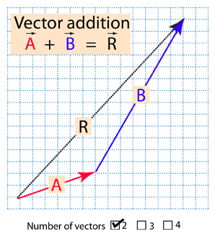

The component method is used as above, where the resulting vector, , is the conjoining side for the triangle constructed from the sum of and .

The Cosine Rule method requires you use the rule to find the magnitude of the resulting vector. However, finding the angle of the resulting vector can prove more difficult and will require the Sine Rule:

**or**

For more information on vector addition with both methods see:  
Component 🡪 <https://www.youtube.com/watch?v=6Kw2nIwWYL0>  
Cosine Rule 🡪 <https://www.youtube.com/watch?v=ZElOxG7_m3c>

### Mathematical Notation for Vectors

In mathematics, vectors are denoted using the same vector arrow but can also be represented as a matrix. This is known as component form. For a 2D vector this would look like:

Vectors are also denoted using notation (linear form). is a vector of length which points along the positive direction; is a vector of length pointing along the positive direction; and is a vector of length which points along the positive direction.

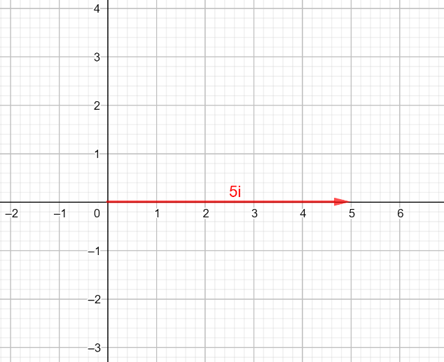So, the vector would look like this:

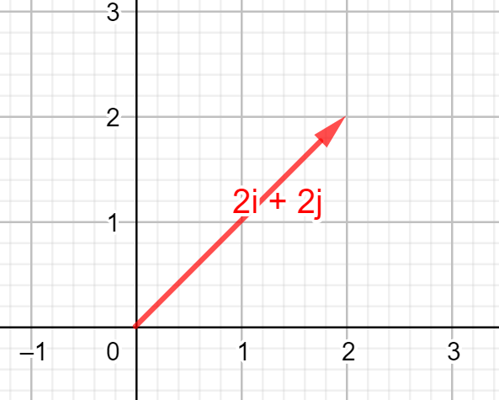Similarly, the vector would look like:

We could have also written as and as

Adding vectors can be best represented using component form:

We can also use linear form to do this, though it is less intuitive:

This is why we break vectors into and components, it makes adding them easier.

### Relative Vectors

Vectors can also be relative to each other; in fact you will find any two vectors are always relative.  
Relative vectors are used to change reference frame

The typical example for this is two trains travelling towards each other at equal and opposite velocities. To an observer outside the trains, both trains appear to be travelling at the same speed. But to someone on one of the trains, the other train appears to be travelling at double the speed.

Relative velocity is often spoken of in terms of *Velocity of A relative to B*.   
What this means is: If you are object B, how fast does object A appear to be travelling.

This can also be used for vector addition, where Velocity of A, relative to B can be drawn as   
By doing this we are shifting into the reference frame of train A.

We can apply this to our trains from before. If both our trains are travelling at *10ms-1* but train A is going North, while train B is going South, then the Velocity of A relative to B is:

The reasoning behind this is that we take the velocity of train A as positive and since train B is going in the opposite direction, we change its direction to North but negative (since it is going South).

Another way of rationalising relative vectors is thinking about the simplest scenario, a moving train passing a stationary person. To the train, the relative velocity of the person is in the opposite direction to the train’s motion. As such, the relative velocity of the person is the negative velocity of the train, as when the train moves past the person while going North, the person appears to be going at the same speed but South.

Now if the person was running South, then they would still appear to be going South, but they would appear to be travelling South faster. This is because they are now running in that direction, so we add their running velocity to the negative velocity of the train to get the final relative velocity.

### A Note on Negative Vectors

When performing vector addition, a negative vector is the reverse of the vector, such that all components have their direction reversed. So, a vector (N 30˚ E) would become (S 30˚ W).

If you are using the traditional vector notation with *x* and *y* components, multiply both components by -1 before adding.

*Vector A: Vector -A:*

# Module 2: Dynamics

## Base Units

Force () – Newtons () **or**

Energy () – Joules () **or**   
Work () – Newton-Metres **or** Joules ()  
Power () – Watts ( **or** )  
Gravity () – Acceleration ()

## Equations

*Newtons is a measure of Force, One Newton is equivalent to one kilogram metres-per-second2 (kg ms-2). The net comes from the fact there can be a force pair on an object where it is immobile, therefore the net force is 0N.*

*Force of friction is equal to the coefficient of friction between two surfaces, μ, multiplied by the force pushing the two together, N (normal force).*

**and**

**and**

**and**

*Component breakdown of the gravity force on an object which is on an inclined slope .*

*Work done by a Force is equal to the dot product of the Force and distance covered. This is the same as the parallel component of the Force to the distance, multiplied by the distance.*

*Work done is also the change in potential energy. If the potential energy goes down, work has been done by the field. If potential energy has increased, work has been input into the system to increase the potential.*

*The ordered kinetic energy of a system.*

*Gravitational Potential Energy – The potential of a gravitational body to do work near Earth’s surface.*

**Proof:**

*Work done in a uniform gravitational system is equal to the negative change in potential energy. An increase in potential energy requires work be done, while if gravity did the work there is a corresponding reduction in potential.*

**Note:**

*Power is work done per second.*

*Momentum: mass multiplied by velocity.*

**Note:**

*Impulse describes change in momentum*

## Course Notes

### Newton’s Laws

#### 1st Law - **Inertia**

“”

This law has a logical derivative which is not often stated but is assumed knowledge in Physics:   
An object that has a uniform state of motion or is not moving has 0 net Force acting on it,   
*i.e. a box hanging from the ceiling has an equal amount of force acting on it from gravity as there is from the string holding it, therefore the force from the string vertically is equal to the force from gravity.*

#### 2nd Law - **Force**

#### 3rd Law – **Law of Pairs**

Any Force will exist in an equal pair. Often these forces are referred to as “reaction forces” however this leads to the misconception that the mere existence of a Force creates another. In actuality, the fact that a force exists demands that another force also exists which is equal and opposite, however it must already exist. For example, a proton attracting an electron. The reaction force is the electron attracting the proton; however, this force is created by the electron due to the electron’s charge, not because the proton is pulling on the electron.

### Friction Forces

Friction is one of the simpler forces that occur in Physics, however, there are a couple of important details to note about friction. The first is that static friction is a **maximum** value. The force of static friction is always equal the force pushing it, otherwise the object would not be “static”.   
Kinetic friction is different. Kinetic friction has a constant value, no matter what velocity the objects are moving at (except ). The force of kinetic friction is always in the opposite direction to the motion of the object.

### Tension Forces

Tension forces can be one of the most confusing part of this topic if you don’t understand it. To summarise, tension force occurs due to bonds between molecules which pulls any two molecules back together. Because there are many thousands of molecules all pulling each other together, the sum of the forces results in two forces, each pulling with equal strength towards the centre of mass of the string but in opposite directions (creating our force pair). Objects like chains can also exert a tension force. *[See Tutorial 1 for practice]*

The tension in a string is the sum of the forces pulling in the direction that would stretch the string.

### Vector Diagrams

Force diagrams, especially solving for components, can get tricky. They require that you are meticulous and aware of all possibilities.

As seen in the first example, the net force is 0N and, as such, the object is at rest. The force due to gravity is the   
mass (m) x acceleration (g)

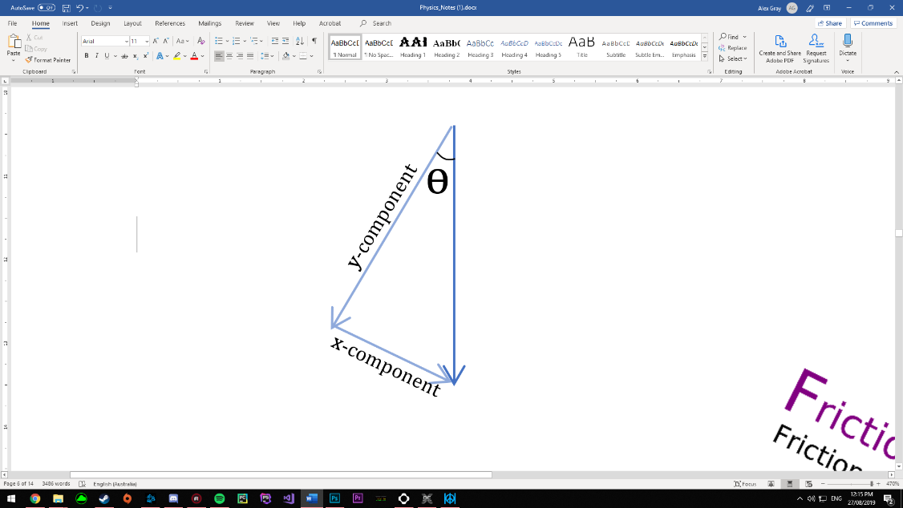

In this example, the vectors are more difficult to figure out. The first thing which we know is that the angle of elevation is equal to the angle the gravity vector makes with its’ y-component. The two components can then be solved by using and .

**ϴ**

The y-component always points perpendicular to the slope and the x-component always points parallel down the slope*.

The y-component is almost always equal and opposite to the normal force.

If the object is in equilibrium (motionless) then the x-component is equal to the Force of static friction.   
If the object is moving, then the x-component is equal to or greater than the Force of kinetic friction.

*This is what is expected for a component breakdown however which directions you choose to break up a vector into is arbitrary and not important. As long as it is broken up correctly (the sum of the components is the original) then it is valid. The trick is knowing which components to break it into for the given scenario.

### Conservation of Energy

The law of Conservation of Energy states that the total energy in a closed system remains un-changed.

Although this law really requires that all energies (including chemical potential) be accounted for, it can be applied to kinetic energy in certain scenarios.

### Conservation of Momentum

The law of Conservation of Momentum is closely related to the law of Conservation of Energy. The law states that momentum in a closed system is always conserved.

This law has led to the development of the terms Elastic and In-Elastic collisions. An elastic collision is one where the ordered velocity of objects before and after is perfectly conserved, or equally, it is a collision where kinetic energy is conserved.

An Inelastic collision is a collision where kinetic energy is converted to heat energy or some other energy. Think about clapping, clap for long enough and your hands get red and warm up, the kinetic energy of the clap has converted to heat, this collision is therefore, inelastic.

It is important to note that momentum is still conserved in this situation, the momentum is merely no longer the ordered kinetic motion of the hand, rather the momentum has transferred to the molecules in the hand and has moved them randomly, increasing heat.

### Collisions

#### Elastic

An Elastic collision is one where both ordered kinetic energy and momentum are conserved (i.e. two objects collide and rebound back).

#### Inelastic

In an inelastic collision, only momentum is conserved (i.e. two objects hit and both stop).

# Module 3: Waves & Thermodynamics

## Base Units

Frequency () – Hertz ( **or** )  
Period () – Seconds ()  
Wavelength () – Metres ()  
Amplitude – Metres ()  
Intensity () – Energy of light in an area – *Luminosity or Candela* ()

Refractive Index of substance- – ()

Speed of Light () – []

Temperature () – Kelvin () **or** Celsius ()  
Thermal Energy () – Joules ()  
Specific Heat () – Joules *per* kg *per* Kelvin ()  
Thermal Conductivity () – Joules *per* metre *per* second *per* Kelvin ()  
Latent Heat () – Joules *per* kg ()

## Equations

### Waves:

*Frequency is the inverse of Period.*

*Universal wave equation, describing the relationship between speed, frequency and wavelength.*

*Beats of interfering waves*

*Doppler Effect – Note that the equation is different to the official formula sheet.*

*The refractive index, , is the ratio of the universal constant, c, to the speed of light in the given substance, .*

*Snell’s Law. Rewritten using different notation but same formula.  
 signifies incidence, signifies refraction.*

**Mathematical Proof from Snell’s Law:** when .

*Critical angle of refraction. The critical angle is defined as the angle at which a light ray will refract to 90˚ from the normal. Any angle > will reflect.*

*The intensity of light in a given area will degrade over a distance as a function of the surface area of a sphere. This equation only applies to a single source at a time.*

### Thermodynamics:

*Internal heat energy will increase dependant on the specific heat, , of a substance and its mass.*

*Latent Heat Formula.  
Heat required for a phase change / to overcome chemical potential of phase.*

**Note:**

Where is not given, take as 1

*The rate of heat transfer (in Watts) of an object where:  
 🡪 Cross-section Surface area  
 🡪 Thermal conductivity of substance  
 🡪 Thickness of object parallel to direction of heat transfer*

## Glossary

|  |  |
| --- | --- |
| ***amplitude*** | The measure of the displacement of the wave from its rest position. The greater  the amplitude of a wave, the greater its energy. |
| ***beats*** | Two sound waves of different frequency add by constructive and destructive  interference producing an alternatively soft and loud sound. |
| ***coherent*** | Two waves are said to be coherent when they have a constant phase difference  between them. |
| ***compression*** | The region in a longitudinal wave where the particles are closest together. |
| ***crest*** | The crest is the highest point of a wave. |
| ***diffraction*** | Diffraction is when a wave remains in the same medium but bends around an  obstacle or passes through an aperture. |
| ***electromagnetic***  ***wave*** | Waves that can travel through a vacuum. They do not need a medium. Light is an  example of an electromagnetic wave. |
| ***equilibrium***  ***position*** | The position the medium would have if there were no wave. It is represented on a  graph by a line through the centre of the wave. |
| ***frequency f*** | The number of crests of a wave that move past a given point in a second. The SI  unit is the Hertz. The frequency is the inverse of the period. |
| ***interference*** | When two waves add together to form a resultant wave of lower or greater or the  same amplitude. |
| ***longitudinal wave*** | A wave where the disturbance moves parallel to the direction of the wave. |
| ***mechanical wave*** | A wave that travels through a medium. Mechanical waves cannot travel through a  vacuum. |
| ***medium*** | The matter that a wave travels through. |
| ***opaque*** | Does not allow light to pass through. |
| ***period T*** | The time between wave crests. The SI unit is the second. It is the inverse of the  frequency. |
| ***progressive*** | A progressive or travelling wave moves away from its source. |
| ***propagation*** | The process by which a wave is transmitted through a medium. |
| ***rarefaction*** | The region in a longitudinal wave where the particles are furthest apart. |
| ***reflection*** | Occurs when a wave bounces off a boundary, changing direction but remaining in  the same medium. |
| ***refraction*** | The change in direction and wavelength when a wave moves from one medium to  another. |
| ***refractive index*** | A number that describes how light travels through a specific medium. Different  mediums have different refractive indexes. The refractive index of a vacuum is defined to be 1. |
| ***resonance*** | The tendency for a system to oscillate with greater amplitude at some frequencies  than at others. |
| ***ripple tank*** | A shallow glass tank of water used to demonstrate the properties of waves. |
| ***signal generator*** | A machine that can produce different patterns of voltage at a range of frequencies  and amplitudes. |
| ***standing wave*** | A wave that remains in a constant position. Also called a stationary wave. |
| ***transducer*** | Converts a signal from one type of energy into a signal of another type; for  example, a sound transducer changes sound energy into electrical energy. |
| ***transparent*** | A material that allows light through, for example, glass. |
| ***transverse wave*** | A wave where the disturbance moves perpendicular to the direction of the wave. |
| ***trough*** | The trough is the lowest part of the wave. |
| ***wave equation*** | The relationship between velocity, frequency and wavelength. v = f λ |
| ***wave velocity*** | The speed at which the wave travels through a medium. The SI unit is ms-1. |
| ***wavelength λ*** | The distance between successive crests or troughs of a wave. The SI unit is the  metre. |

## Course Notes

### Image result for properties of wavesProperties of Waves

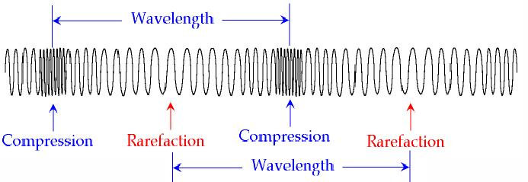

### Frequency and Period

Frequency is defined as the number of oscillations of a wave in one second.  
Period is defined as the time taken for one oscillation to occur.

### Energy of a Wave

The energy of a wave is determined by many factors and while there are equations for the energy of waves, they are not covered in this course. However, for any given wave, the energy is proportional to its **amplitude**.  
A practical example of this is the fact that louder music has a larger amplitude.

A sound wave with double the amplitude has double the energy. However, the energy of a wave will change depending on many other factors including wavelength and frequency, so the Amplitude is only relevant to a wave where all other factors are constant.

### Transverse vs Longitudinal

#### Transverse Waves

A transverse wave is defined as a wave where the axis of propagation is perpendicular to the axis of oscillation (i.e. a light wave).

#### Longitudinal Waves

A longitudinal wave is defined as a wave where the axis of propagation is parallel to the axis of oscillation (i.e. a sound wave).  
Any compression wave is a longitudinal wave.

### Graphing Compression Waves

Graphing a wave such as a sound wave may seem unintuitive, however there are two different ways to graph a compression wave.  
1: Displacement  
2: Pressure

The displacement method graphs the average distance between particles at a given point on the wave.  
The pressure method graphs the air pressure of the wave at a given point.

These two methods are the inverse of each other (as when displacement is large pressure is low etc.) however the graph will still show the same wave.

### The Ray Model

Light is often modelled using a ray model. This model is a gross simplification of how light behaves, however in the context it is used, it is accurate enough for correct calculations to be made.

The reason the ray model works is that parallel light rays interfere with each other in such a way that only a ray is visible. What this means is the ray model is applicable to any situation where photons may be travelling in parallel, however it is not applicable to situations where a single wave is present.

It is also applicable because light travels across perfectly straight lines along space-time. (Unless space itself is curved)

### Refraction

All waves possess the property of refraction. When a wave moves from one substance to another, its’ speed changes. Going from a slower medium to a faster medium will bend the wave away from the normal.  
Going from a faster medium to a slower medium will bend it towards the medium.

This refraction can be imagined using the *wavefronts*.

### Image result for wavefrontsWavefronts

Any wave can be drawn using wavefronts. The wavefront image is often used to explain refraction using a “marching soldiers” metaphor.   
Although this metaphor is inaccurate, if it helps with understanding then use it.  
[*Explanation of how refraction of light really works*](https://www.youtube.com/watch?v=NLmpNM0sgYk)

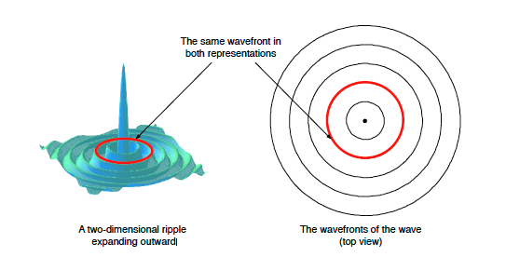A wavefront is a line perpendicular to the motion of the wave and denotes the point of highest amplitude. Therefore, the distance between fronts is the wavelength ().

### Refractive Index

The refractive index, as defined earlier, denotes the ratio of the universal constant to the velocity of light in a given substance. The larger the refractive index, the slower light travels through that substance.   
It is impossible to have a refractive index smaller than 1.

#### Refraction and Refractive Index

In relation to Refraction, given that light bends towards the normal when going into a slower substance, we can also say it bends towards the normal when going into a substance with a larger refractive index.

The inverse is also true when going into a faster substance. The ray will bend away from the normal when travelling into a faster medium as it will bend away from the normal when going into a substance with a smaller refractive index.

### Diffraction

Another property of waves is diffracting around obstacles.

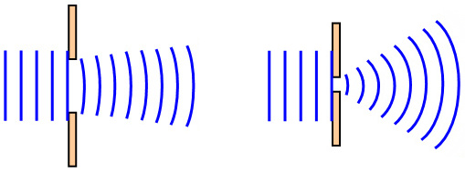When the gap between two obstacles is much greater than the wavelength, there is little to no diffraction.  
As the gap approaches the size of wavelength and gets smaller, more diffraction will occur.

### Huygens’ Principle

This principle states that all points on a wave are a source of a smaller wave.

It is often stated that only wavefronts are sources and that they are sources of wavelets, however this is disingenuous to Huygens.

If you imagine a water wave, the reason it waves is because of how water interacts with itself under gravity. As a water molecule moves away from another water molecule, it attracts that molecule to it. However, there is a small delay since the force the first molecule exerts gets stronger with the distance from the other molecule.  
So, after a small delay, the other molecule starts moving with its neighbour. And then that molecule does the same thing to its next neighbour. The delay of the interaction is the speed of sound in that material.  
The same logic applies to pushing molecules closer together except the force is repulsive and gets stronger the closer they get.

So, if a particle in a wave is moving, it is pulling and pushing on its’ neighbouring particles.

If all other particles immediately stopped moving, that particle would become a source of a new wave, no matter what stage of its ‘waving’ it was in.

This is the reason waves diffract. The walls act as the ‘suddenly stop’ function.

Huygens’ principle can be written mathematically and must be true for any wave however it would merely be restating the above in a much less useful way.

### Superposition

Waves possess the ability to superimpose themselves on other waves of the same type.  
Light waves and sound waves will interfere with themselves, but a light wave cannot interfere with a sound wave and visa-versa.

Superposition is responsible for many phenomena, including beats and resonance.  
A simple way to add the waves is as though they are sine functions on a graph.

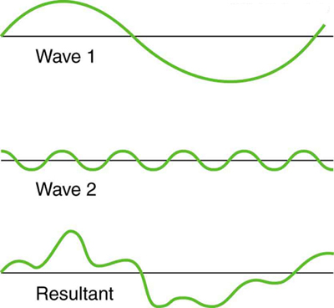

Superposition, as with the above, results in beats, where the amplitude of the wave oscillates at a different frequency to the frequency of the wave.

### The Doppler Effect

The Doppler Effect is a phenomenon with any wave that occurs when the relative velocities of the observer and the source are different. When the source moves, the frequency of the wave changes.  
When the source moves in the same direction as the wave, the wavelength shortens.  
When the source moves in the opposite direction of the wave, the wavelength lengthens.

The Doppler Effect is slightly different when the observer moves. When the observer moves the apparent frequency of the wave changes, but the actual frequency does not.

When the observer moves *towards* the wave (in the opposite direction of the wave), the observer observes more oscillations per second, increasing the apparent frequency.  
When the observer moves *away* from the wave (in the same direction as the wave), it is as though the observer is running away from the wave, as such they observe less oscillations per second than the actual frequency, lowering the apparent frequency.

### The Doppler Effect Equation – A Strange Mistake

On the 2019+ HSC Physics formula sheet, you will note that the doppler effect equation is given as:

**This equation is wrong, do not use it**.

Now, I say it is wrong, however, this is not necessarily the case. Let’s state the assumptions of the above formula:  
*The direction of the wave is the positive direction.*

*The observer is by default, travelling towards the wave. Therefore, the formula takes the observer’s direction as positive when it is travelling in the pre-defined negative direction.*

*The source is by default, travelling with the wave, and its’ direction is positive when it is going in the same direction as the wave.*

But this is stupidly confusing and so I have concluded that it is functionally worse than useless.

What we notice about this formula is you can re-write it to be much simpler.

The *-* sign on the top now allows us to use this single assumption:

*The direction of the wave is the positive direction for all vectors.*

So, there we go, the newly adjusted formula works for the doppler effect and allows the use of normal vector addition.

### Standing Waves

Standing waves occur as a result of superposition within a system. A standing wave is a wave where the direction of propagation of the wave is 0, i.e. it is not moving. However, the direction of propagation of energy is still present. In a standing wave, the wave does not propagate because there is an equal amount of energy propagating in either direction, meaning that at any point on the wave, there is an equal amount of energy travelling in both directions, causing the appearance of a “standing” wave.

### Resonance

There is a very complex explanation of how resonance works, regarding air pressure and frequency of oscillation at a given end of a tube. Because of this, diagrams vary in consistency across the internet. However, here is a close guide to what you need to know.

Here is the simple explanation:

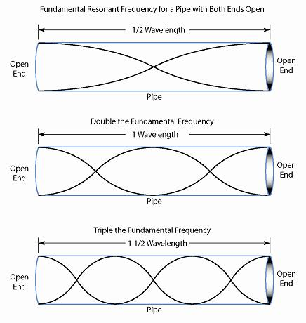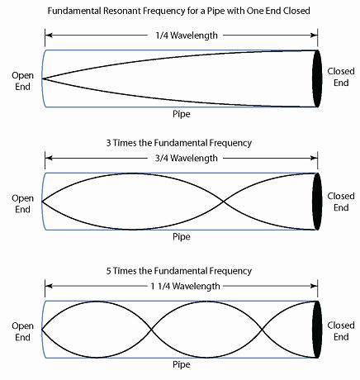Resonance occurs when a [standing wave](https://www.youtube.com/watch?v=-k2TuJfNQ9s) is able to be formed with a *node* or *anti-node* at each end. For a tube with air, the fundamental resonant frequencies are as such:  
**One Open – One Closed: Both Open or Both Closed:**

Following these resonant frequencies, the next consecutive frequencies will be the base   
frequency +. This is the case no matter what combination of end types.

One rule for drawing resonance is that at an open end, you draw an anti-node and at a closed end you draw a node.

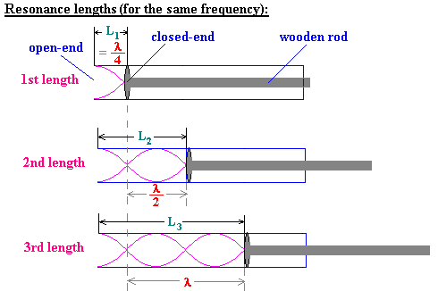

### Entropy

Entropy describes the relative disorder of particles. Entropy is a measure of how disordered a given substance is at a given temperature and, as such, is measured in .

For Year 11 Thermodynamics, this unit is less relevant.

Entropy is the Second Law of Thermodynamics and states that the measure of average entropy () will never decrease, only remain the same or increase.   
The law also describes the tendency for a thermodynamical system to approach thermal equilibrium over time. In essence, heat will spread out over time until the distribution of Entropy is even.

The final important note of the law is that heat moves from hot to cold, or more specifically, Work must be done to move heat energy from something cold to something warm.

### Specific Heat

Specific heat is a property of all matter, with a *specific* value for each substance at each phase (s, l, g). Specific heat describes the heat energy (in Joules) required to heat one kg of that substance by one degree Kelvin.

Specific heat exists because of the different potential energies between molecules. The stronger a chemical bond, the more energy must be put in to increase the velocities of each particle. Therefore, substances with stronger bonds require more heat energy to increase their internal kinetic energy by the same amount.

### Latent Heat

Latent heat describes the phase change between solid and liquid and, liquid and gas.

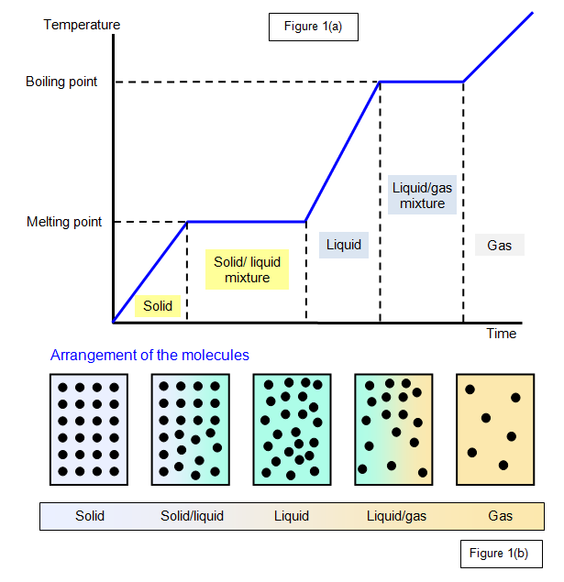There is no simple explanation for latent heat that works, so here is the simplest one:  
*Latent heat is the amount of heat energy required to increase the kinetic energies of the molecules past the escape velocities of the inter-molecular bonds of each phase.  
This latent heat is only measured once a state of fusion or vaporisation has been reached, as such, latent heat is the amount of heat energy which is input which only goes towards breaking chemical bonds, not raising the temperature.*

### Thermal Conductivity

Thermal conductivity is another inherent property of matter which denotes how quickly heat can be transferred through the substance per area.

Objects like metals or liquids which have free flowing particles (metals have electrons) are able to more effectively transfer heat than a rigid material like salt.

### “The Speed of Light”: The Universal Constant - c

In the above Units section, is listed “Speed of Light () – []”. This number is a special number because it is a Universal Constant. If you are uninterested, just remember this as the speed of light.

This ‘Universal Constant’ exists as such because it is the maximum speed at which anything can move in our universe. It is even the maximum relative velocity and is the speed at which light can be observed to move, no matter what speed you are travelling at.

Another property of The Speed of Light is that anything without mass in the universe will move at this speed. Light is the most common thing to move at this speed, however things like gravity waves and electric fields propagate at the speed of light.

The Speed of Light was assigned the letter “c” because it is “the constant”. No matter what, it is the only thing in the universe which cannot be exceeded. It is also known as the “speed of causality”, signifying that information itself is limited by this speed.

# Module 4: Electromagnetism

## Base Units

Charge () – Coulombs ()  
Electric Field () – Newtons *per* Coulomb ()  
Voltage () – Volts ( **or** )  
Current () – Amperes ( **or** )  
Resistance () – Ohms ()  
Conductance () – Mhos (S)  
Magnetic Flux Density () – Teslas () **or** Newtons *per* metre *per* Ampere ()

## Constants

Charge of Electron ()   
Charge of Proton ()

Mass of Electron ()   
Mass of Proton ()

Electric Permittivity Constant ()   
Magnetic Permeability Constant ()

## Equations

*Force on a charged particle due to an Electric field.*

*The strength of an Electric field caused by particle , at a given radius, .*

**Mathematical Explanation:**

*Describes the Force on particle due to field emitted by .  
Also describes the force on particle due to field from .*

*The equation describes the full pair of forces (Newton’s 3rd Law).*

*The work done in an Electric field, moving a particle a distance. It describes the change in potential energy in the field.*

*The Electric Potential Energy of a charged particle in a uniform Electric field at distance.  
It describes the potential of the system to do Work.*

*This equation is only true when the particle is able to be moved by the field. If the particle is restricted from moving, like by a plate, then the potential is zero.*

*The Electric Potential Energy of a charged particle in an Electric field caused by another particle at distance.  
It describes the potential of the system to do Work.*

*The Electric Potential of any charged particle in a field. Voltage is the Electric Potential Energy per Charge.*

*Current is measured in charges per second (Coulombs per second)*

*Ohm’s Law*

*Power output (Watts) of a circuit.*

**or**

**or**  **or**

**or**

*Current, Voltage and Resistance in Series Circuits*

Note: ‘’ means *sum of all* from *1* to *n*.

**or** **or**

**or**

**or**  **or**

*Current, Voltage and Resistance in Parallel Circuits*

*Conductance of a resistor. (I have no idea why it’s G)*

*Strength of a Magnetic Field in a wire with a flow of electrons.*

*Strength of a Magnetic Field in a uniform Solenoid.  
 is the number of loops per metre.*

## Course Notes

### Fields

Fields are a strange topic as they are not traditionally observable and can interfere with each other in strange ways. Fields can be thought of as being emitted by all things which possess the given property the field requires. Gravity fields are “emitted” by all objects with mass, Electric fields by everything with a charge. The other thing fields appear to be is a constant. Just as The Universal Constant is the maximum speed anything can move at through space; Fields appear to exist as a Universal Constant. There is no reason for fields to exist, they merely do.

There is also a constant behaviour of Fields, they apply a Force per unit of fundamental that thing possesses. Gravitational Fields apply a force per unit mass and Electric Fields apply a force per unit charge.

The reason they can only be thought of as being emitted is because they are always present. The electromagnetic field is present throughout all of space and a charged particle merely excites that field. It is similar with gravity however space itself is the gravitational field.

### Force Pairs of Fields

As shown by Coulomb’s Law:   
and Newton’s Law of Universal Gravitation: ,  
Fields exert a force on an object and the force exerted by object *a* on *b*is equal to the force exerted on *b* by *a*. Therefore, when using Coulomb’s Law, both Forces in the pair are being found, such that one Force, , is equal to .

This allows momentum to be conserved as the net force in the universe is 0.

### Electric Potential Energy

Electric Potential Energy is a difficult concept to grasp as it differs depending on what particles are present and their charges. For a particle which is attracted by the field being emitted, the Potential Energy of that particle is , where *d* is the distance from the field emitter.

For a particle which is repelled by the field it gets harder. In this case the particle must be contained by something like a capacitor, otherwise the particle’s Potential Energy is infinite (*d* is infinite).   
If the particle is contained, take *d* as the distance from the point at which it can no longer move   
(i.e. the wall of the capacitor).

### Electric Potential and Electric Potential Difference – Voltage

Electric Potential is Voltage and describes the Potential Energy per Coulomb of a charge in a given uniform field.

Voltage is also known as Electric Potential Difference. A better explanation is that Voltage drop is the difference in Electric Potential of two points. As such, there can be a voltage between two points in an Electric Field emitted by a proton, as the difference in the Electric Field and distance for the two points will change the Voltage.

Voltage is not Electric Potential Energy, however since it is Potential Energy per Charge, multiplying Voltage by the Charge will get the Potential Energy of a Particle or the Work done on a Particle by a system.

In a circuit, Voltage at a point is a measure of the Kinetic Energy per charge, and a Voltage “drop” measures the decrease in kinetic energy per Coulomb of each electron.

### Current

Current is a measure of Coulombs per second. In reality, this is electrons passing per second however, since they have a charge in Coulombs, it is measured in Coulombs per second.   
Current does not necessarily denote velocity (that is Voltage), rather it denotes how many electrons are passing in parallel. Given even a small wire can be thousands of atoms thick, thousands of electrons can be passed through the wire next to each other at once. This is how current can increase / remain constant while Voltage decreases.

### Electrical Kinetic Energy and Power

Electrical Energy is akin to the amount of kinetic energy the electrons in a circuit possess. Increasing the Energy output by a circuit is done by increasing potential energy of the electrons in the circuit   
In doing so this increases the current which is the number of electrons passing per second.   
As such, an increase in Voltage will increase the kinetic energy of the electrons.

This is how we get the law .   
It is the kinetic energy per charge lost through the circuit, multiplied by the number of charges per second passing through the circuit. This is what gives us our energy per second.

### Resistance

Resistance is a property of every form of matter, the higher the resistance of a substance, the more insulating it is. Resistance, measured in Ohms , denotes how much energy is taken away from the electrons as they pass through that object.

As stated before, Electrical Energy is the energy of all the electrons in a circuit. As such, a resistor must slow down the electrons and convert the lost energy into something like heat, sound or motion. Any device which uses electrical energy is an appliance of electrical resistance to perform a task.

A good analogy for Resistance is like trying to shoot a bullet completely straight through something like a dense forest. Theoretically it’s possible but more likely is that the bullet will deflect slightly off a tree and lose energy. This is the same but instead of a bullet, use an electron, and instead of trees, the atoms of the resistor.

Although this is just an analogy and doesn’t properly represent the true mechanics of resistance, it may help with understanding.

#### The Slightly more complicated explanation

Electrons in a circuit all travel at the same speed. When a voltage is applied to a circuit it propagates down the circuit at the speed of light (i.e. there is a slight time delay at the end of the circuit before it ‘knows’ a voltage has been applied).  
This delay is enough to make the electrons push on each other and, in doing so, allows the conductor to conduct the field around the circuit. It is almost like pushing beads through a curved hose. As you push on each bead it pushes on the next bead and the force is redirected around the curve.

The resistance is how much the material stops the field from being conduced through the material.

What this means is that, in reality, the electrons aren’t being slowed down by the material because they were never going too fast. Instead, the field spends some of the energy it would have spent pushing the electrons trying to push the wires of the circuit and this is what gives rise to resistance.

### A Strange Property of Resistance

A somewhat strange behaviour of resistors is Ohm’s Law () which states that an increase in current across a resistor will increase the Voltage drop across that resistor. If we define Voltage in a circuit as a measure of Kinetic Energy per charge, then as we increase the number of electrons flowing into the resistor, we also increase the amount of energy lost per electron as it passes through.

### Electron Spin and Magnetism

Electrons possess two fundamental properties which allow them to create magnetic fields.  
1. Charge  
2. Quantum Spin

Electrons are magnetic, it is a fundamental property of Electrons due to their spin. However, Electrons are also quantum and, as such, are random.  
Electrons *basically* have a North and South pole, however, their rotation is random. This concept is known as spin and it describes the fact that when an Electron encounters a magnetic field it has a 50% chance of being spin-up and 50% chance of being spin-down. Once the electron encounters the field, it becomes one of these spins and is attracted to magnets as such, where spin-up places the North pole of the electron towards the magnet, and spin-down the South.

Traditionally Electrons exist in electron shells and inside those, in pairs. These pairs, unless forced by another magnet, always exist with one spin-up and one spin-down electron, resulting in the cancellation of the magnetic fields. An object becomes magnetised when the outer orbitals which contain a single electron all possess an electron which has a spin direction parallel to all or most of the other atoms in the object. The more outer single electrons in their own orbital, the more magnetic a substance can be.

Electrons also create magnetic fields by moving as this is the traditional way in which a magnetic field is created.

### Magnetic Fields

Fundamentally, Magnetic Fields are caused by Electrons and their spin arrangement or by moving charges. Magnetic fields interact with objects and each other in the same way Gravitational and Electric Fields do, where the stronger the magnetism of an object, the greater the force exerted on it by a magnetic field.

Unlike Electric Fields, where a singular point charge can emit a spherical field, magnets always exist with two poles, almost like having an electric field due to an electron and a proton being stuck to each other. As such, a magnetic field will always have some form of interference and behave like a typical bar magnet diagram.

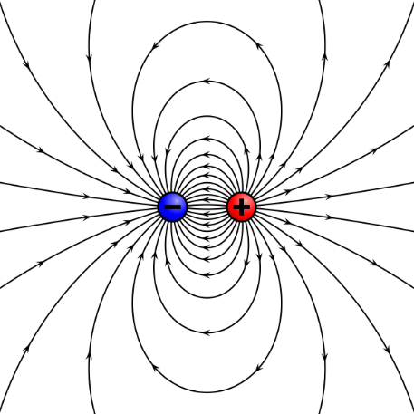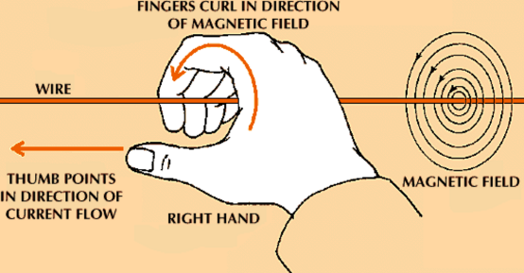Magnetic Fields can also be caused by current flowing through a wire. The direction of the magnetic field’s rotational flow is a cross () multiplication and as such, can be denoted using the right-hand rule.

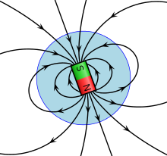

*Comparison of Magnetic Fields and Electrostatic Fields*

### Magnetism in a Wire with Current

Although the direct explanation of this phenomena is very difficult to understand mathematically, see Veritasium’s video on the topic for a visual explanation: <https://www.youtube.com/watch?v=1TKSfAkWWN0>

In short, the video above details how special relativity and length contraction explains electromagnets.  
The contraction of distances between charges along the vector of motion increases the density of negative charge along the wire and creates the magnetic field.

### Magnetism in a Ferromagnet

As with the above, magnetism in a permanent magnet is a little difficult to explain. What we know is that permanent magnets exist because of all the outer valence electrons being able to exist in their own orbits and then align their magnetic moments (spin) in the same direction, generating a net magnetic field.

The difficulty is that although it’s possible to calculate the magnetic moment of an electron with extreme accuracy, it is somewhat unclear how it produces that field. One possible explanation is that since electrons spin, the rotation of its electric charge causes relativistic effects which cause it to create a magnetic field.

### Magnetic Field Lines

Magnetic field lines are a little different from Electric field lines as they show the direction a small magnet would be aligned at that spot in the field.

The force on a moving charge in a magnetic field is also perpendicular to this field line.

# Appendix

### Tension

This type of question can pull a sneaky one on you in the final exam.

20kg

15kg

28˚

1. What is the Force rotating the pulley clockwise?
2. What is the Force rotating the pulley anti-clockwise?
3. Given the coefficient of Static Friction, 0.3, what direction will the system rotate?
4. Given the coefficient of Kinetic Friction, 0.2, calculate the acceleration of the system.
5. Calculate the tension in the string holding the masses.
6. If the system would rotate clockwise, then the resisting force will be the force down the slope + friction.  
    🡪

The system will rotate clockwise

2. Given we know the acceleration clockwise is 0.58ms-2, we can say that the Net Force down on the 15kg block must result in this acceleration. Therefore:

The tension in the string is this upwards force (138.3N up)